Topic 3, 3.2 & 3.3 Carbohydrates, Lipids, Proteins, and DNA Assessments Statements

- Distinguish between organic and inorganic compounds.

a.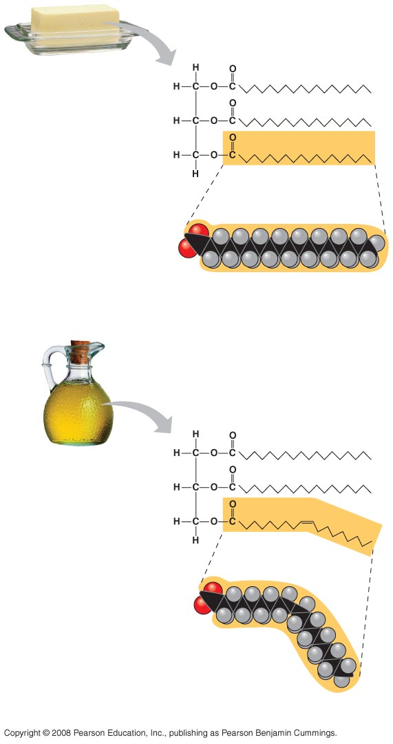 b.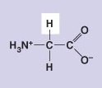 c.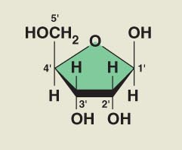 d.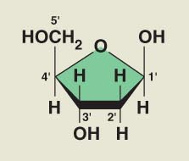 e.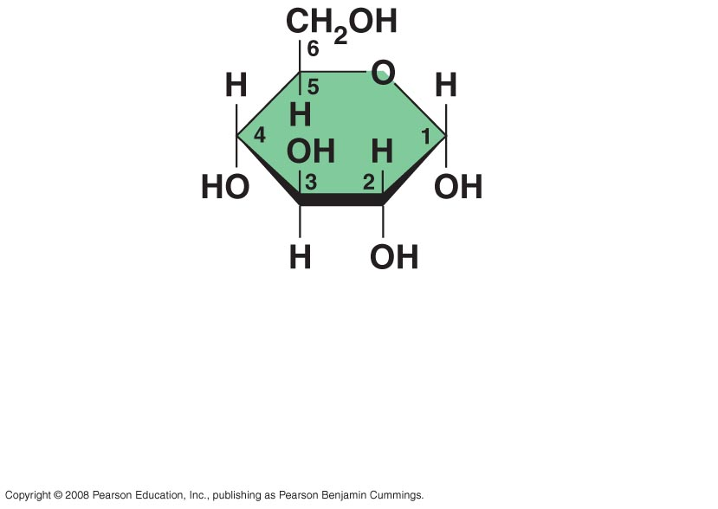

- Identify the following using the images above: amino acids, glucose, ribose and fatty acids from diagrams showing their structure.

- List three examples each of monosaccharides, disaccharides and polysaccharides.

- State one function of glucose, lactose and glycogen in animals, and of fructose, sucrose and cellulose in plants.

- Outline the role of condensation and hydrolysis in the relationships between monosaccharides, disaccharides and polysaccharides; between fatty acids, glycerol and triglycerides; and between amino acids and polypeptides.

- Compare the use of carbohydrates and lipids in energy storage.

- Outline DNA nucleotide structure in terms of sugar (deoxyribose), base and phosphate.

- Outline how DNA nucleotides are linked together by covalent bonds into a single strand.

- Explain how a DNA double helix is formed using complementary base pairing and hydrogen bonds.

- Describe the structure of DNA, including the antiparallel strands, 3’–5’ linkages and hydrogen bonding between purines and pyrimidines.

