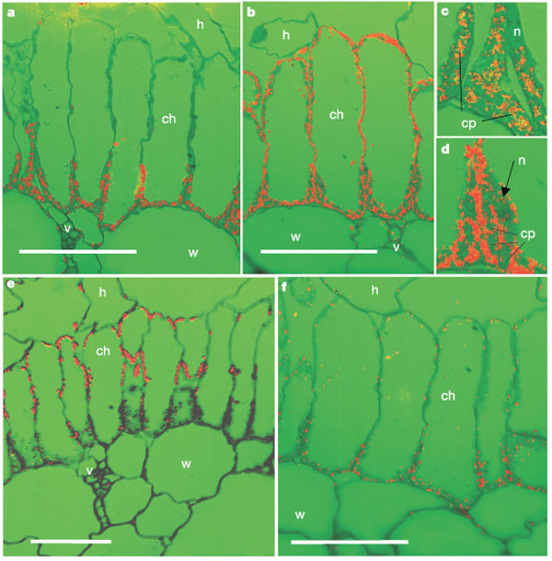
Immunolocalization of Rubisco (a), PEP carboxylase (b), higher magnification showing Rubisco in chloroplasts in proximal end of cell (c), higher magnification showing PEP carboxylase in cytosol (d), pyruvate,Pi dikinase (e) and NAD-malic enzyme (f). Red dots indicate where the enzyme is present. cp, chloroplast; ch, chlorenchyma cell; h, hypodermal cell; n, nucleus; v, vascular tissue; w, water storage cell. Scale bars, 50 μm.
From the following article:
Kranz anatomy is not essential for terrestrial C₄ plant photosynthesis
Elena V. Voznesenskaya, Vincent R. Franceschi, Olavi Kiirats, Helmut Freitag and Gerald E. Edwards
Nature 414, 543-546(29 November 2001)
doi:10.1038/35107073

- For figure “e” above, calculate the magnification of the image.
  - Within figure “e” is a cell labeled “ch.” Calculate the length of this cell in micrometers.

- For figure “f” above, calculate the magnification of the image.
  - Within figure “f” is a cell labeled “ch.” Calculate the length of this cell in micrometers.

