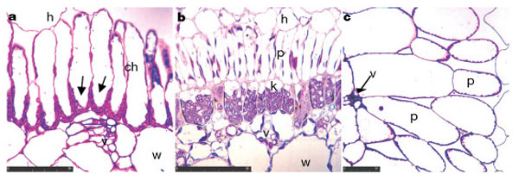
a, Borszczowia aralocaspica; b, Salsola laricina; and c, Suaeda heterophylla. ch, chlorenchyma cell; h, hypodermal cell; k, Kranz cell; p, palisade cell; v, vascular tissue; w, water storage cell. Scale bars, 50 μm.
From the following article:
Kranz anatomy is not essential for terrestrial C₄ plant photosynthesis
Elena V. Voznesenskaya, Vincent R. Franceschi, Olavi Kiirats, Helmut Freitag and Gerald E. Edwards
Nature 414, 543-546(29 November 2001)
doi:10.1038/35107073

- Calculate the magnification of each figure, “a,” “b,” and “c.”

- For figures “b,” and “c,” calculate the actual length, in microns, of the cells labeled “p.”

