Chapter 15 Part III Questions

- Explain the two common causes of nondisjunction.

- Describe the general term which describes the result of nondisjunction?

- Draw the following chromosomal alterations: deletion, duplication, inversion, translocation.

- What happens when a a deletion becomes attached to another chromosome?

- Humans and chimpanzees are two primates that are said to be related, and there is a lot of scientific evidence to support these claims. If you look at the figure below, you will see one piece of this evidence. There are four pairs of chromosomes with the human chromosome on the left and the chimpanzee chromosome on the right. How would you explain these results?
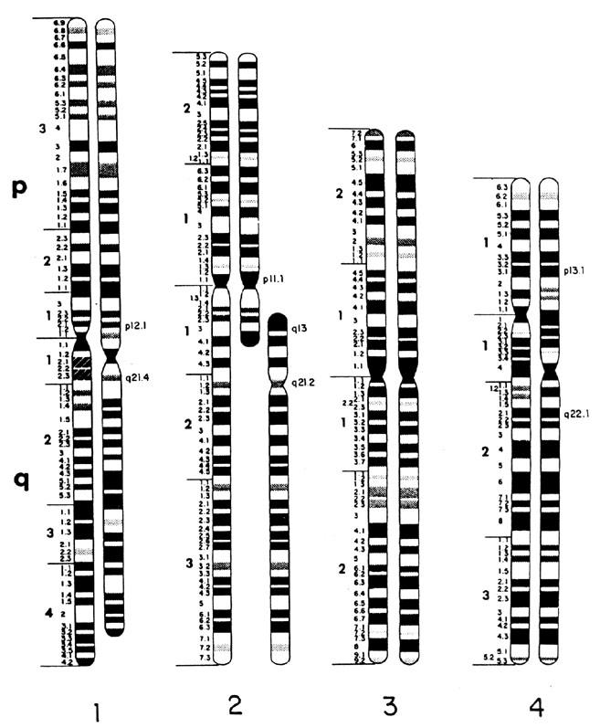
Figure courtsey of http://www.indiana.edu/~ensiweb/lessons/chr.bk1.html

- List a chromosomal abnormality associated with a chromosomal abnormality. Explain its cause.

- Explain what is meant by the term extranuclear genes? Give an example.

- What organism’s DNA does the description of mitochondrial DNA resemble? What does this support.

