Chapter 6 Assessment Statements—Liver Ultrastructure

- Label the following diagrams which show of the ultrastructure of liver cell.
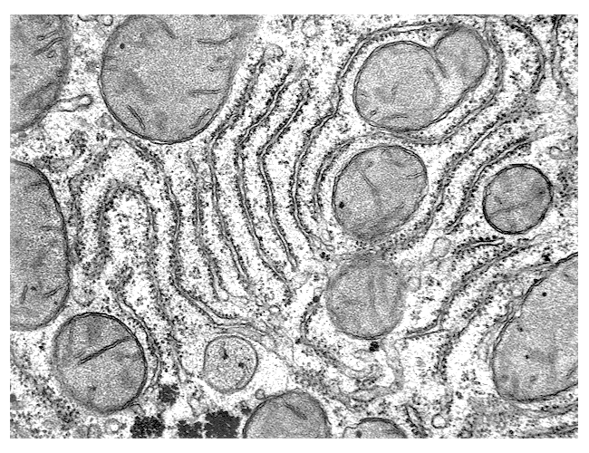
http://www.udel.edu/biology/Wags/histopage/empage/el/el.htm
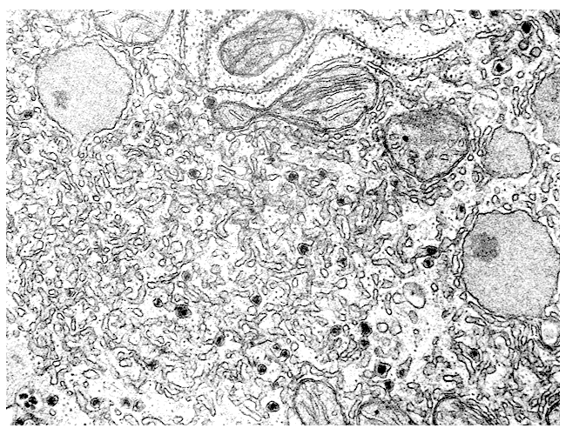
http://www.udel.edu/biology/Wags/histopage/empage/el/el.htm

- Annotate the following diagram of the liver cell’s ultrastructure, name the structures numbered 1, 2, 5, 6, 7, 8, 9, 10, and 11, and list the functions of each named structure.
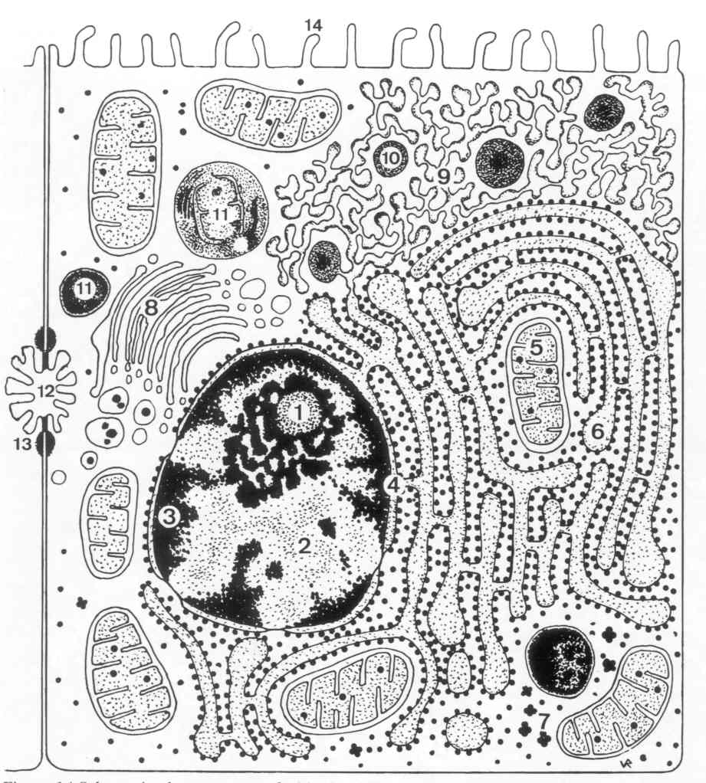
http://homepage.smc.edu/wissmann_paul/physnet/anatomynet/anatomy/thecell.html

- Identify structures from diagram of the liver cell in electron micrographs of liver cells.

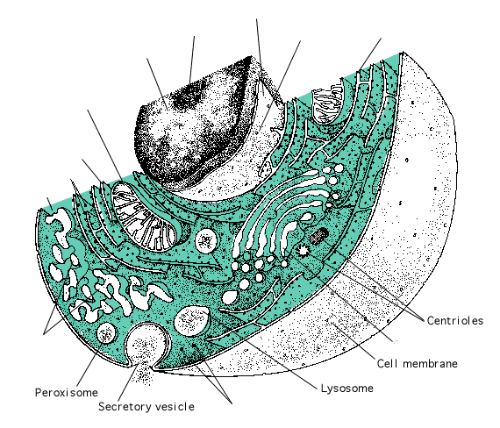
http://en.wikibooks.org/wiki/

- Compare prokaryotic and eukaryotic cells.

- State three differences between plant and animal cells.

- Outline two roles of extracellular components.

