Ultrastructure of Prokaryotic Cells

1. Label the following structures in the diagram below: pili, plasma membane, cytoplasm, ribosomes, flagella, chromosome, cell wall.

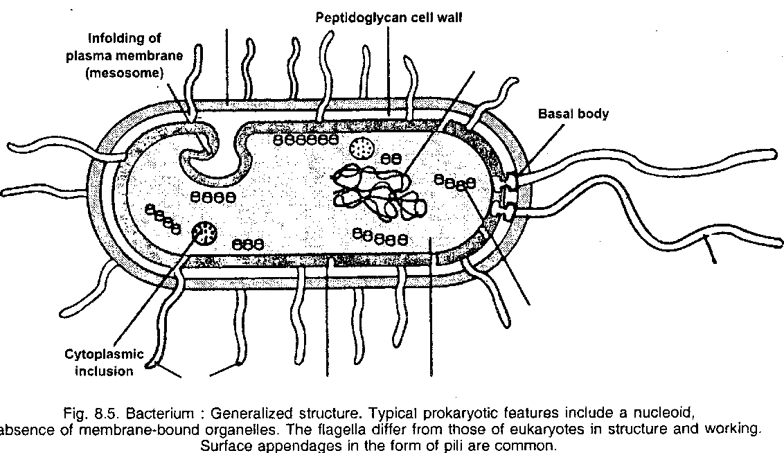

2. Label the following structures in the diagram below: cell wall, flagella, pilus, cytoplasm, nucleoid, ribosome, polyribosome.

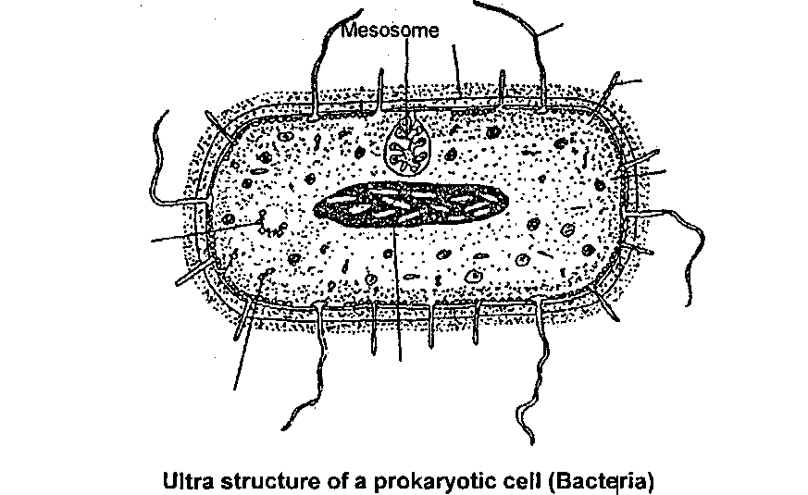

3. In the diagram below, put the following words in the correct boxes: cell wall, ribosomes, nucleoid.

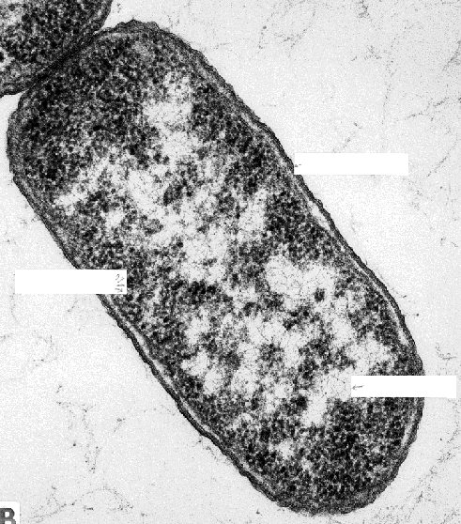

4. Label the following structures in the diagram below: Cytoplasm, plasma membrane, cell wall, nucleoid, ribosomes.
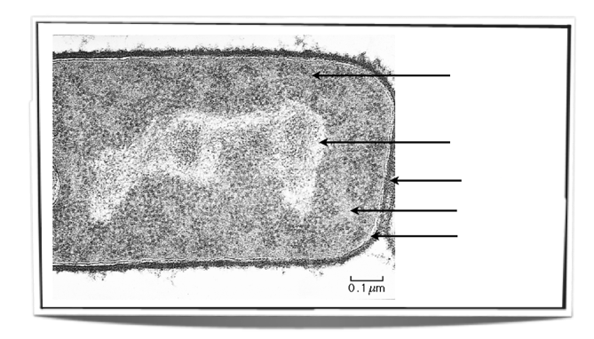
5. Identify the flagella and pili on the diagram below.

